PENETRATION TESTING REPORT
FOOTPRINTING, RECONNAISSANCE
& LOCAL NETWORK SCANNING
CYBERSECURITY PRACTICAL REPORT

Report Detail | Information
Pentester Name | Tanish Soni
Program / Batch | Networkwalks Cybersecurity Program | Batch B084
Report Date | 13 November 2026
Modules / Activities | Footprinting & Reconnaissance; Local Network Host Discovery
Client / Target | networkwalks.com (reconnaissance) and local LAN subnet scanning.
Authorization | Domain testing: use only within the permission granted for the assigned practical. LAN scan: own or explicitly authorized local network.
Operating Environment | Kali Linux

Prepared for educational and authorized security assessment purposes.

1. Liability Disclaimer
The activities documented in this report are intended for education and research. Testing must be limited to systems, domains and devices for which written permission or other valid authorization has been obtained. Do not use these techniques to access, disrupt or test third-party systems without permission. The author is responsible for ensuring that all actions remain within the approved scope and applicable laws.

2. Introduction
This report documents two practical activities: footprinting and reconnaissance of the networkwalks.com domain using Kali Linux tools, followed by host discovery on the local 192.168.29.0/24 network using Nmap. The first activity gathered publicly observable domain, DNS, web-technology, HTTP-header and WAF information. The second activity identified devices that responded during a host-discovery scan of the stated local subnet.
The report records the commands used, the observations shown in the supplied terminal output, and the security relevance of those observations. The Nmap output was provided as text; a separate Nmap screenshot was not included in the supplied evidence set.

3. Tools Used
Tool | Purpose
Kali Linux | Operating system used for reconnaissance and network discovery.
WHOIS | Collect publicly available domain registration, registrar, status and name-server information.
WhatWeb | Identify web technologies and application components exposed by the website.
NSLookup | Resolve a domain name to an IP address using DNS.
cURL (-I) | Retrieve and inspect HTTP response headers.
WAFW00F | Check for a detectable Web Application Firewall.
DNSRecon | Enumerate publicly available DNS record information.
Nmap (-sn) | Perform host discovery across the local subnet without a port scan.

4. Activities Performed

4.1 Footprinting & Reconnaissance
Reconnaissance was performed against networkwalks.com using six tools. Each tool was selected to collect a different category of publicly observable information.

4.1.1 WHOIS Lookup
Command executed:
whois networkwalks.com
WHOIS returned domain registration details, including the registrar (GoDaddy.com, LLC), registration and expiry dates, domain status values, name servers and DNSSEC status. The output also displayed registrar contact and ICANN reference information.
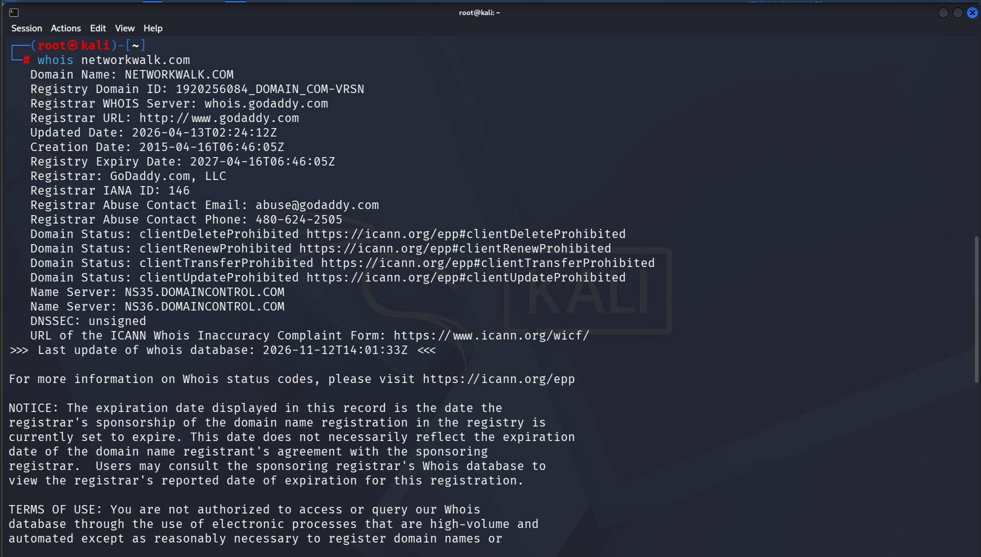
Figure 1. WHOIS lookup output for networkwalks.com.

4.1.2 Website Technology Identification
Command executed:
whatweb networkwalks.com
WhatWeb identified Apache as the web server and WordPress as the content management system. The captured output reported WordPress 7.1.4, jQuery 3.7.1, Bootstrap 7.1.4, the page title NetworkWalks Academy, and other response details. These are tool-reported fingerprints and should be independently verified before being treated as confirmed software versions.
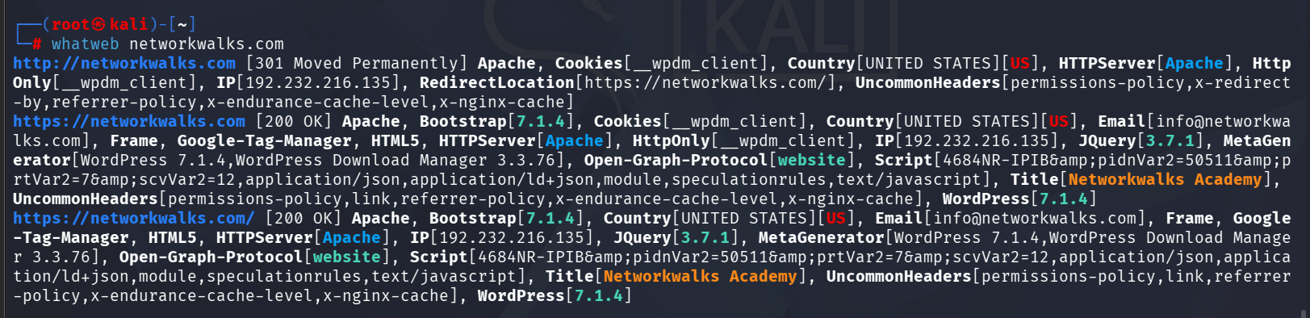
Figure 2. WhatWeb technology fingerprinting output.

4.1.3 DNS Lookup
Command executed:
nslookup networkwalks.com
NSLookup queried the configured DNS server 192.168.13.2 and returned the address 192.232.216.135 for networkwalks.com. This confirmed that the domain resolved successfully at the time of the test.
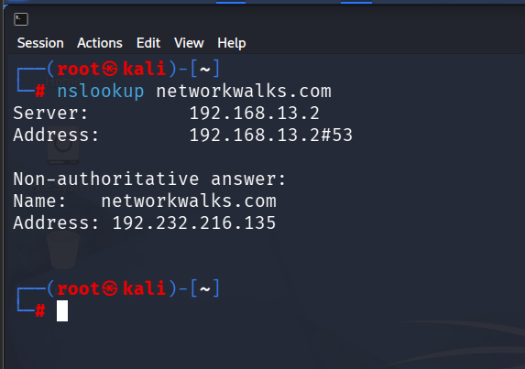
Figure 3. NSLookup result resolving networkwalks.com.

4.1.4 HTTP Header Analysis
Command executed:
curl -I https://networkwalks.com
The HTTP HEAD request returned HTTP/1.1 200 OK. The response included the Apache server header, Content-Type information, cookie attributes and several policy or platform-related headers. Header disclosure can assist technology fingerprinting; the presence of a header does not, by itself, establish a vulnerability.
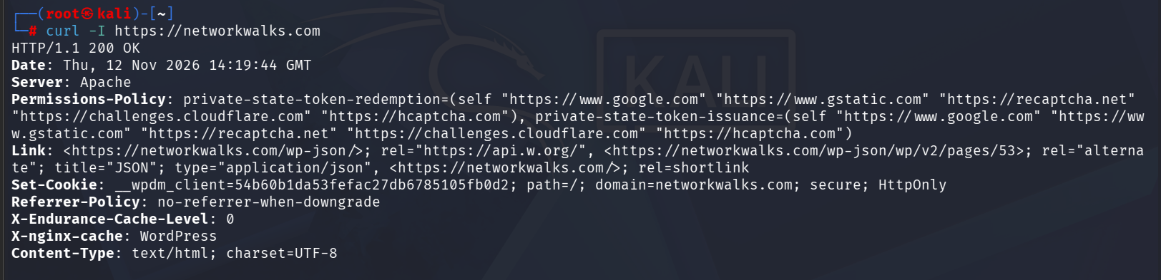
Figure 4. cURL HTTP response-header output.

4.1.5 Web Application Firewall Detection
Command executed:
wafw00f networkwalks.com
WAFW00F reported that https://networkwalks.com is behind ModSecurity (SpiderLabs) WAF. The tool reported two requests for this detection. This is a fingerprinting result and does not demonstrate that every attack is blocked or that the WAF is correctly configured.
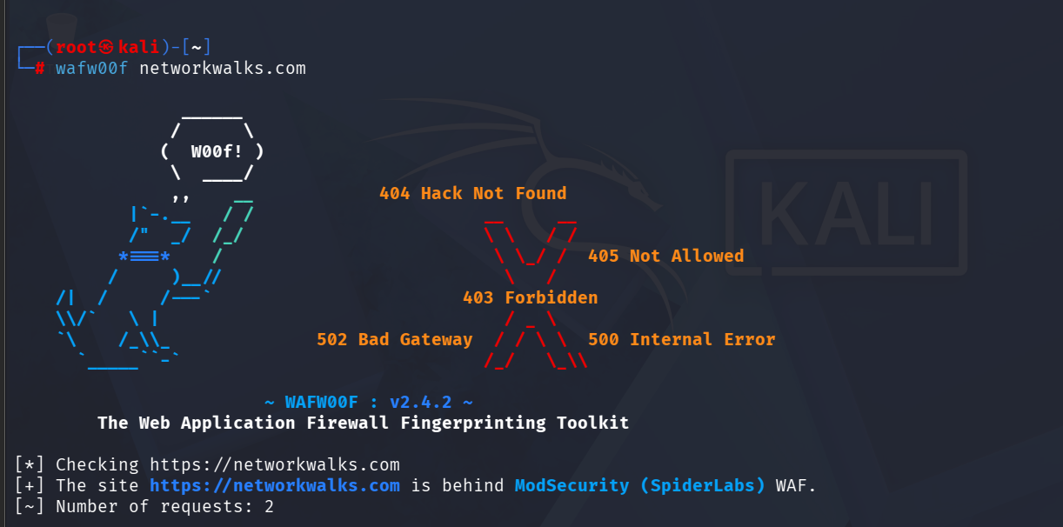
Figure 5. WAFW00F output identifying ModSecurity (SpiderLabs).

4.1.6 DNS Enumeration
Command executed:
dnsrecon -d networkwalks.com
DNSRecon reported SOA, NS, A, MX, TXT and SRV record information. The output included the domain A record 192.232.216.135, name-server details, mail-related information and TXT records including SPF and Google site-verification values. The tool reported eight records found. DNSRecon also displayed a DNSSEC query error; therefore, the error should be retained as part of the observed result rather than interpreted as proof of a broader DNS failure.
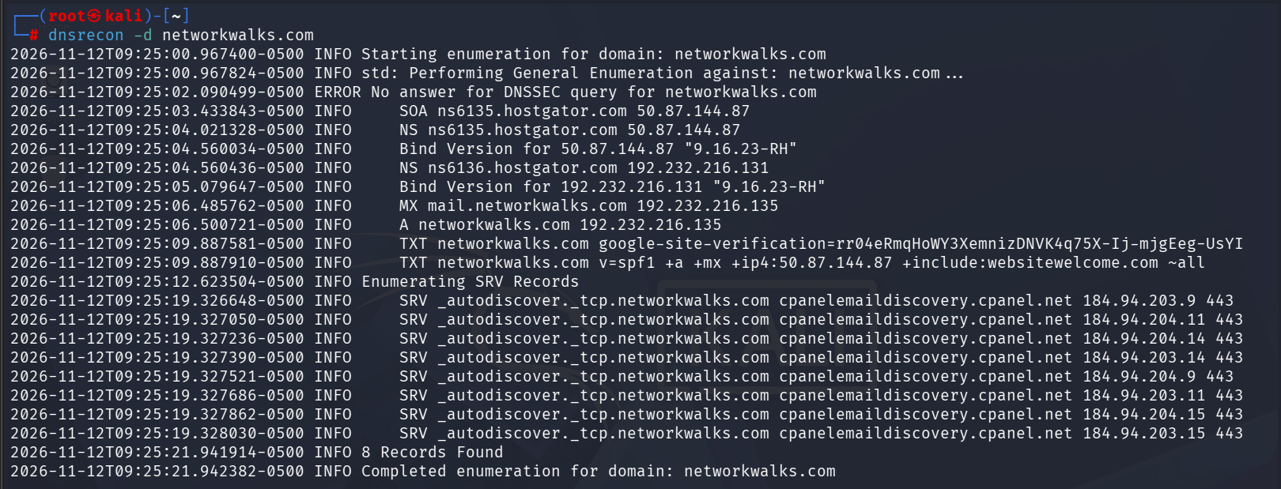
Figure 6. DNSRecon enumeration output.

4.2 Local Network Scanning & Host Discovery
A host-discovery scan was performed on the local subnet 192.168.29.0/24. The purpose was to identify IP addresses that responded during the scan and collect MAC-address information where Nmap reported it.
Command executed:
sudo nmap -sn 192.168.29.0/24
Nmap reported 256 IP addresses scanned and 11 hosts up. The following table transcribes the live-host and MAC-address information supplied in the scan output.
No. | Live Host IP | MAC Address | Vendor / Observation
1 | 192.168.29.1 | 9C:D4:A6:3D:CA:F1 | Servercom (India) Private Limited
2 | 192.168.29.8 | AA:4A:5E:09:3E:4E | Unknown
3 | 192.168.29.26 | 76:01:2D:40:25:A5 | Unknown
4 | 192.168.29.51 | 24:B1:05:1D:35:CB | Prama Hikvision India Private Limited
5 | 192.168.29.52 | 24:B1:05:1D:36:72 | Prama Hikvision India Private Limited
6 | 192.168.29.53 | 24:B1:05:3D:DA:62 | Prama Hikvision India Private Limited
7 | 192.168.29.54 | 24:B1:05:1D:36:76 | Prama Hikvision India Private Limited
8 | 192.168.29.55 | 24:B1:05:1D:36:73 | Prama Hikvision India Private Limited
9 | 192.168.29.91 | 24:B1:05:3A:46:59 | Prama Hikvision India Private Limited
10 | 192.168.29.202 | C8:40:52:11:8A:D7 | PAX Computer Technology (Shenzhen)
11 | 192.168.29.162 | Not reported | Not identified in supplied output

Nmap displayed MAC addresses for ten of the eleven hosts. No MAC address was shown for 192.168.29.162 in the supplied output. The host may be the scanning machine or may simply have had no MAC address reported in that scan context; this should be verified locally rather than assumed. Vendor identification is based on the MAC-address lookup reported by Nmap and does not confirm the exact device model or owner.
Scan summary: 256 IP addresses scanned; 11 hosts reported up; 10 MAC addresses displayed.

5. Risk Analysis / Impact
The observations below describe potential information exposure or network visibility. They are not confirmed vulnerabilities. Risk levels are preliminary and should be reviewed in the context of the asset owner, business requirements and authorized assessment scope.
# | Risk / Finding | Evidence / Observation | Potential Impact | Risk
1 | Web technology details exposed | WhatWeb reported Apache, WordPress and related components. | May help an attacker select technology-specific research or tests. | Low
2 | Domain IP address identifiable | NSLookup resolved networkwalks.com to 192.232.216.135. | Provides a publicly observable address associated with the domain. | Low
3 | HTTP response information visible | cURL returned HTTP 200 and server/platform-related headers. | May assist service fingerprinting and further enumeration. | Low
4 | WAF technology identifiable | WAFW00F reported ModSecurity (SpiderLabs). | Reveals a defensive technology in the application environment. | Low
5 | DNS records publicly enumerable | DNSRecon returned SOA, NS, A, MX, TXT and SRV information. | Can help build a profile of public DNS and mail infrastructure. | Low
6 | Multiple live devices visible on LAN | Nmap identified 11 live hosts, with 10 MAC addresses reported. | Unexpected or unmanaged devices could increase the network's attack surface. | Medium

Risk key: Critical / High / Medium / Low. The reconnaissance and host-discovery activities did not include exploitation or vulnerability validation. A visible software version, DNS record, HTTP header, WAF fingerprint or live host does not by itself prove that a system is vulnerable.

6. Recommendations
- Review publicly exposed technology information and ensure that CMS, plugins and server components are maintained and patched.
- Review HTTP response headers and remove unnecessary technical disclosures where practical; configure security headers according to application requirements.
- Maintain DNS records carefully and periodically review public records for accuracy and unnecessary exposure.
- Keep the WAF enabled, updated and monitored; validate its rules through authorized testing rather than assuming detection alone proves protection.
- Maintain an inventory of devices connected to the local network and investigate devices that are not recognized.
- Segment sensitive devices, including cameras or other IoT equipment, from general user networks where appropriate.
- Repeat authorized network discovery periodically and document changes in live hosts and device identifiers.
- Perform any further security testing only with explicit authorization and within the approved scope.

7. Conclusion
The practical activities covered domain footprinting, reconnaissance and local network host discovery. WHOIS provided domain registration information; WhatWeb identified web technologies; NSLookup resolved the domain name; cURL inspected HTTP response headers; WAFW00F reported a ModSecurity (SpiderLabs) WAF fingerprint; and DNSRecon enumerated DNS record information.
The local Nmap host-discovery scan covered 192.168.29.0/24 and reported 11 live hosts, with ten MAC addresses shown in the supplied output. This exercise demonstrated how host discovery can provide an initial view of devices visible on a local subnet. It also highlighted the importance of validating device ownership and maintaining an accurate asset inventory.
Overall, the exercises reinforced that reconnaissance and scanning are foundational stages of a security assessment. Findings must be documented accurately, interpreted cautiously and followed by recommendations that are appropriate to the authorized scope.

8. Evidences Collected
The following screenshots were supplied as evidence for the six footprinting and reconnaissance commands. The Nmap host-discovery output was supplied as text in the conversation; insert a terminal screenshot of that scan here before final submission if the assignment requires visual evidence.
Evidence 1 – WHOIS domain lookup
Evidence 2 – WhatWeb technology identification
Evidence 3 – NSLookup DNS resolution
Evidence 4 – cURL HTTP header inspection
Evidence 5 – WAFW00F detection
Evidence 6 – DNSRecon enumeration

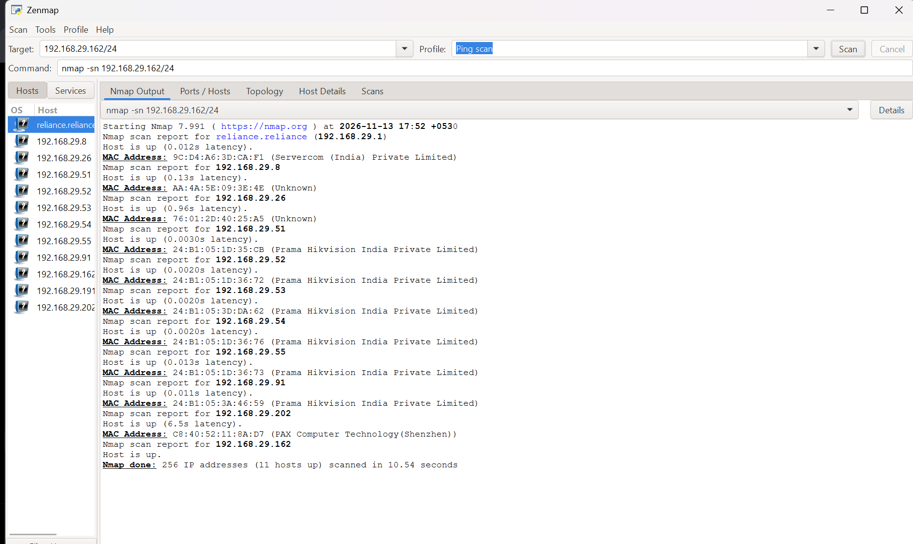
Evidence 7– Nmap Scanning (host discovery )

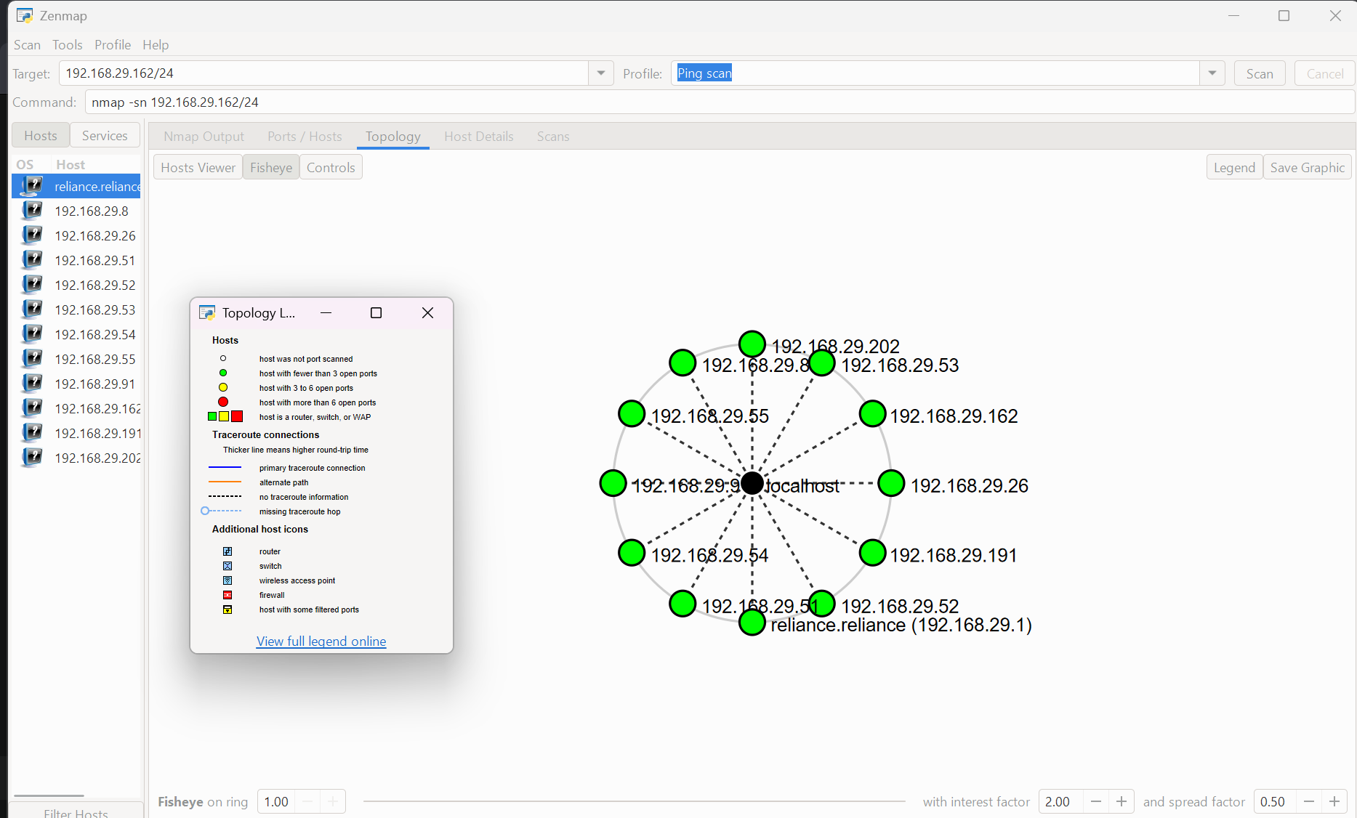
Evidence 7 – Topology

9. Author & Project Information
Field | Details
Author | Tanish Soni
Program | Cybersecurity Program – Networkwalks
Batch | B082
Practical Focus | Footprinting, Reconnaissance and Local Network Host Discovery
Repository | GitHub – add repository URL before final submission

— End of Report —

